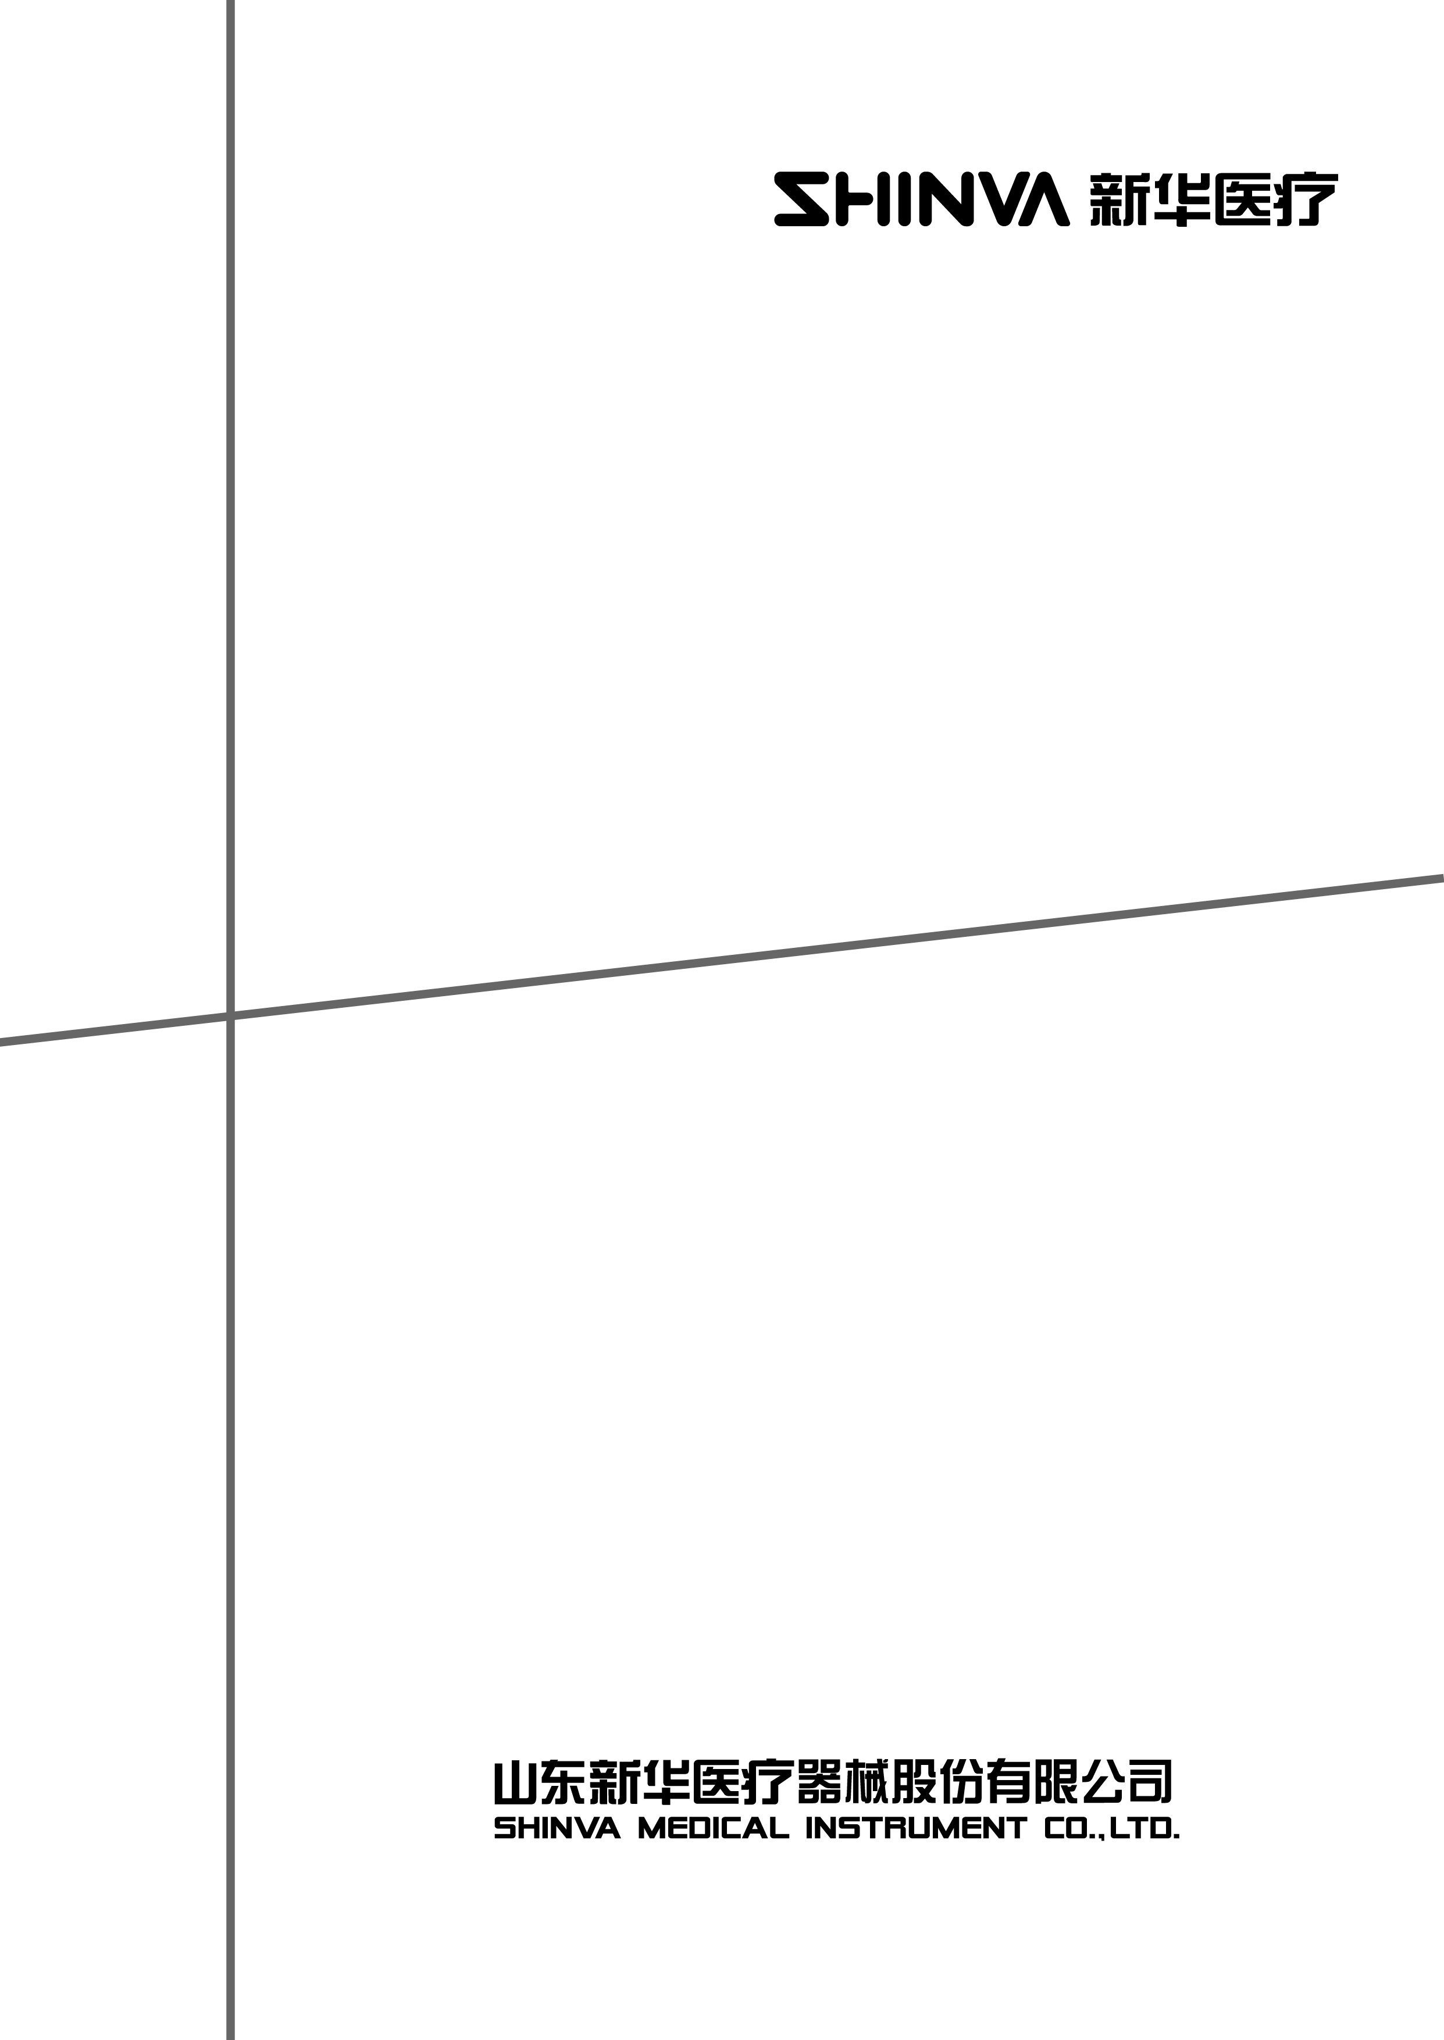

Ultrasonic Washer
User Manual
QX2000

File No: TD-UT-B150-001 V2.01
Date of publication: 2014-4-12

Welcome use SHINVA Ultrasonic Washer. To maximize the performance of the equipment, please carefully read and comply with this manual for safety and operational purpose.

This manual is applicable to the installation, operation and maintenance of SHINVA QX2000, QX2000-D, QX2000-S, QX2000-C, and QX2000-G Ultrasonic Washer.

The standards that SHINVA Ultrasonic Washer complies with:
Manufacture information
- Medical instrument manufacturer license NO.
Shandong Food and Drug Instrument Supervision Manufacturer No. 20100024
- Registration address:
Xinhua Medical Scientific Zone, Zibo New & Hi-Tech Industrial Development Zone, Shandong Province, P. R. China
- Manufacturing site:
No. 2009 Xinhua Ave, Zhoucun, Zibo, Shandong, P. R. China
Product information
- Medical instrument registration No.
Shandong Zibo Food and Drug Instrument Supervision Approval 2011 No. 1570003
- Product standard: YZB/Shandong Zibo 0003-2011
- Product features:
The ultrasonic washer adopts ‘cavitation effect’ generated by ultrasonic vibration to wash the medical instruments. It consists of host, flushing sink and drying sink.
- Scope of application:
It is widely used for processing medical instruments such as scalpel, haemostatic forceps, tweezers, needle, injector, test tube, glass tube, dressing bowl, dish, bucket, pressure tester, etc. This ultrasonic washer has perfect performance especially for processing those instruments with deep hole, blind hole and concave-convex surface.
- Product contraindications: None.
- Design service life: 8 years.
- Storage condition: None.
- Processing method: Ultrasonic washing, 40KHz
- Working principle:
QX2000 ultrasonic washer uses high frequency oscillation signal, which sent out by ultrasonic generator, and converts to high frequency mechanical oscillation signal and diffuses into the cleaning fluid. The ultrasonic spreads forward in the cleaning fluid to generate millions of tiny bubbles. During the process called ‘Cavitation’ the bubbles implode immediately to generate high pressure and impacts the articles to spall the fouling adhered on the surface and gap of the articles to achieve cleaning purpose.
- Packing and transportation: Complied with Standard GB/T 191

Contents
1. Product introduction 2
1.1. Brief description 2
1.2. Technical parameters 2
1.3. Main features 2
1.4. Order code 4
1.5. Working condition 4
1.6. Environmental conditions 4
1.7. Safety performance 5
2. Routine maintenance 5
2.1. Control system 5
2.2. Routine operation 5
2.2.1. Ultrasonic sink 5
2.2.2. Flushing sink 6
2.2.3. Drying sink 7
2.3. Program instruction 8
2.3.1. Program of ultrasonic washing sink 8
2.3.2. Program of flushing sink 9
2.3.3. Program of drying sink 10
2.4. Manual operation (only for equipment maintenance) 11
2.4.1. Ultrasonic washing sink 11
2.4.2. Flushing sink 11
2.4.3. Drying sink 12
3. Announcements 12
4. Fault handling 13

Product introduction

Brief description
QX2000 series ultrasonic washer adopts most advanced transistor, integrated circuit, microprocessor, protective circuit and digital display. It is well-structured with reliable working performance, high efficiency and low noise. To better meet the needs of users, QX2000 series ultrasonic washer is also equipped with two optional sinks: high-pressure flushing sink and drying sink.
- High-pressure flushing sink
It works with enhanced circulating pump and nozzles. The instruments will be washed, flushed, oil-supplied and disinfected in this sink.
- Drying sink
This sink adopts high quality heater and blowing fan to effectively dry the instruments.

Technical parameters
- Ultrasonic power (kVA): 2kVA±10%
- Ultrasonic frequency (Hz):
Signal frequency: 40±10%kHz
Double frequencies: 40±10%kHz/100±10%kHz
Three frequencies: 40±10%kHz/80±10%kHz /100±10%kHz
- Rated power（kVA）：Washing sink / Flushing sink 11.5 kVA
Drying sink：3.0 kVA
- power： AC 380V±38V、50Hz±1Hz
- Design dimension:
Overall dimension: L800xW640xH800mm
Sink dimension: L600xW420xH330mm
- Dimension of optional sinks:
High-pressure flushing sink: Overall dimension: L800xW640xH800mm
Sink dimension: L600xW420xH330mm
Drying sink: Overall dimension: L800xW640xH800mm
Sink dimension: L600xW420xH330mm

Main features
Ultrasonic washing is a systematic process. In practical application, it is usually used together with high-pressure jet washing and medical soak washing.
The ultrasonic washing has following advantages:
High accuracy: The ultrasonic energy could pass through the tiny gap and hole of the instrument.
High speediness: Relative to normal washing method, ultrasonic washing is a faster and cost-effective method which could improve efficiency and save labor force.
Consistency: Regardless of the size or structure of the instrument, the ultrasonic washing could achieve homogeneous performance.
The comparison with normal washing methods is shown as follows:
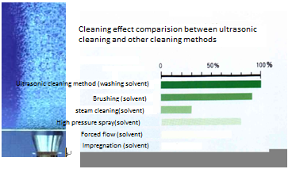
As can be seen, ultrasonic cleaning method exceeds the conventional general cleaning methods, especially on cleaning the instrument with more complex surface such as the surface is uneven, or with a blind hole, ultrasonic cleaning replaces the traditional immersion cleaning and pressure washing. High efficiency and high cleanliness of ultrasonic washer thank to penetrability and cavitation shock waves that are generated while the acoustic wave spreading in medium produce. So it is easy for cleaning equipment with complex shape, cavity and pore. For the general oil removal and anti- rust, they can be finished just within two or three minutes under the role of ultrasound in, its speed can improve several or dozens of times than that of traditional method, clean degree also can reaches a high standard.

Order code
QX □—□

Ultrasonic frequency type or auxiliary function slots

Specification

Ultrasonic washer

Name | Mark | Meaning
Specification | 2000、1500 etc. | Ultrasonic power value
Ultrasonic frequency type | No mark | Single frequency
 | D | Double frequencies
 | S | Three frequencies
auxiliary function slots | C | Flushing sink
 | G | Drying sink

Order code | Function | Notes
QX2000 | Ultrasonic washing | Host
QX2000-C | Ultrasonic washing, flush, oil-supply, disinfection | Host equipped with flushing sink.
QX2000-G | Ultrasonic washing, drying | Host equipped with drying sink.
QX2000-CG | Ultrasonic washing, flush, oil-supply, disinfection, drying | Host equipped with flushing sink and drying sink.

Working condition
Power supply: 380V/50Hz, AC
Water supply: softened water

Environmental conditions
- Temperature: 10~40℃
- Relative humidity: 30%~85%
- Conditions of placement
- Keep away from source of ignition.
- Keep away from direct sunlight.
- Keep the equipment in horizontal position.
- No vibration.
- Keep away from volatile and flammable substance.
- Keep away from corrosive drugs.
- Good ventilation.
- Keep away from interference source, such as electromotor and electromagnetic equipment.

Safety performance
The safety performance complies with State Pharmaceutical Administration Standard GB9706.1-1995.
Electric safety class: Class I Type B
Note: The safety device of the equipment is installed on the control panel. It can be seen once you remove the protective cover of the control panel. If the right light is on means the fuse is burnt that needs to be repaired.

Routine maintenance

Control system
QX2000 series ultrasonic washer adopts single-ship AT89C52 as main processing chip to achieve automatic control. It adopts LCD as human-computer interface and flexible program to facilitate user operation.

Routine operation

Ultrasonic sink
Controller panel
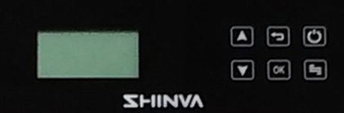
NO. | Name | Instruction
1 | screen | Showing working stage and parameters
2 | increase key  | For choose parameter, increase and decrease the parameter
3 | Decrease key 
4 | ESC  | Quit the parameter setting
5 | Ok  | For confirm or choose the program
6 | ON/OFF key  | For open and off the power
7 | Setting key  | For set parameter

Preparation work before starting the equipment:
- Turn on the main power switch.
- Push the switch button.
- Push the OK button and carry out the preparation work as follows:
Inject water to marked level and heat it to 40℃. Ultrasonic starts working for 20 minutes and the alarm sounds. Now add cleaning detergent.
Calculation formula of detergent dosage:
Detergent dosage = (6000 x concentration ratio)ml
Ultrasonic washing:
- After preparation work, put the instruments that to be washed into the basket and place it in the ultrasonic sink. Push the OK button to start.
- Take the instruments out from the sink when the alarm system prompts the program is finished. Pack up the instruments and get ready for sterilization.
Preparation work before shutting down the equipment:
- Make sure there are no instruments in the washer to be processed.
- Push and hold the up-arrow button while push the down-arrow button for 3 seconds and loosen these two buttons at same time to start discharging water.
- Push the ESC button as soon as the water is totally discharged from sink.
- Push the power button and turn off the main power supply to finish the intraday work.

Flushing sink
Controller panel

NO. | Name | Instruction
1 | screen | Showing working stage and parameters
2 | increase key  | For choose parameter, increase and decrease the parameter
3 | Decrease key 
4 | ESC  | Quit the parameter setting
5 | Ok  | For confirm or choose the program
6 | ON/OFF key  | For open and off the power
7 | Setting key  | For set parameter

Preparation work before starting the equipment:
  - Turn on the main power switch.
  - Push the switch button.
  - Ready for flushing the instruments.
Oil-supply disinfection for the instruments:
- After preparation work, put the instruments that to be washed into the basket and place it in the ultrasonic sink. Push the OK button to start.
- Take the instruments out from the sink when the alarm system prompts the program is finished. Put the instruments into the drying sink.
Preparation work before shutting down the equipment:
- Make sure there are no instruments in the washer to be processed.
- Push the power button and turn off the main power supply to finish the intraday work.

Drying sink
Controller panel

NO. | Name | Instruction
1 | screen | Showing working stage and parameters
2 | increase key  | For choose parameter, increase and decrease the parameter
3 | Decrease key 
4 | ESC  | Quit the parameter setting
5 | Ok  | For confirm or choose the program
6 | ON/OFF key  | For open and off the power
7 | Setting key  | For set parameter
Preparation work before starting the equipment:
  - Turn on the main power switch.
  - Push the switch button.
  - Ready for drying the instruments.
Instrument drying:
- After preparation work, put the instruments that to be dried into the basket and place it in the drying sink. Push the OK button to start.
- Take the instruments out from the sink when the alarm system prompts the program is finished. Pack up the instruments and get ready for sterilization.
Preparation work before shutting down the equipment:
- Make sure there are no instruments in the washer to be processed.
- Push the power button and turn off the main power supply to finish the intraday work.

Program instruction

Program of ultrasonic washing sink
- Procedure
Water-in heating ultrasonic water-out end
- Parameter setting
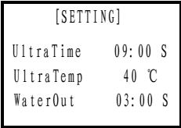
P4
Push the setting button to enter into P4 interface.
Select the editing status by pushing the setting button.
Push the up-arrow button to increase the parameter value.
Push the down-arrow button to decrease the parameter value.
- Suggested parameters
Ultrasonic time: 10~15mins
Ultrasonic temperature: 25~60℃
Drain time: 0~6mins
- Push and hold the setting button for 3 seconds to go back to the initial interface.

Program of flushing sink
- Procedure
Flush 1 Flush 2 oil-supply disinfection cooling end
- Parameter setting
Push the setting button to enter into P5 interface.
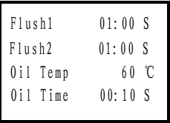
P5
Push the setting button persistently to enter into P6 interface.
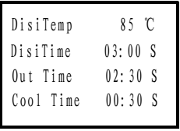
P6
Push the setting button to enter into P4 interface.
Select the editing status by pushing the setting button.
Push the up-arrow button to increase the parameter value.
Push the down-arrow button to decrease the parameter value.
- Suggested parameters
Flush time: 01~03mins
Disinfection temperature: 93℃
Disinfection time: 3mins
Oil-supply temperature: 60℃
Oil-supply time: 20secs
Drain time: 2mins
The relation of A0 value and time and temperature
A0=3000 A0=600 A0=60
80℃/3000s 80℃/600s 80℃/60s
85℃/950s 85℃/190s 85℃/19s
90℃/300s 90℃/60s 90℃/6s
- Push and hold the setting button for 3 seconds to go back to the initial interface.

Program of drying sink
- Procedure
Blow fan works heating timing cooling end
- Parameter setting
Push the setting button to enter into P7 interface.
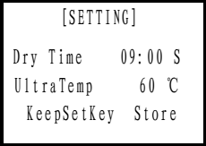
P7
Push the setting button to enter into P4 interface.
Select the editing status by pushing the setting button.
Push the up-arrow button to increase the parameter value.
Push the down-arrow button to decrease the parameter value.
- Suggested parameters
Drying time: 15~30mins
Drying temperature: 40~130℃
- Push and hold the setting button for 3 seconds to go back to the initial interface.

Manual operation (only for equipment maintenance)

Ultrasonic washing sink
Push and hold the setting button for 5 seconds to enter into P8 interface.
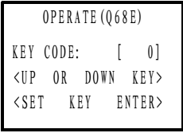
P8
Push the up-arrow button to increase the password value.
Push the down-arrow button to decrease the password value.
After entering the password “11”, push the setting button to enter into P9 interface.
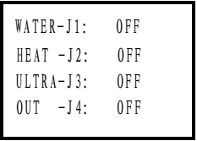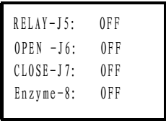
P9
Push the setting button to select and activate certain part(s).
Push the up-arrow button to turn on/off the part.
Push the down-arrow button to turn on/off the part.
Push the ESC button to go back to the initial interface.

Flushing sink
Push the up-arrow button to increase the password value.
Push the down-arrow button to decrease the password value.
After entering the password “11”, push the setting button to enter into P10 interface.
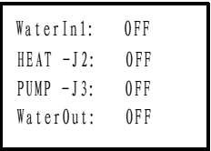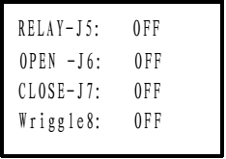
P10
Push the setting button to select and activate certain part(s).
Push the up-arrow button to turn on/off the part.
Push the down-arrow button to turn on/off the part.
Push the ESC button to go back to the initial interface.

Drying sink
Push and hold the setting button for 5 seconds to enter into P8 interface.
Push the up-arrow button to increase the password value.
Push the down-arrow button to decrease the password value.
After entering the password “11”, push the setting button to enter into P11 interface.
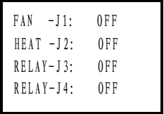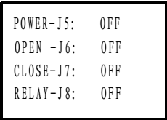
P11
Push the setting button to select and activate certain part(s).
Push the up-arrow button to turn on/off the part.
Push the down-arrow button to turn on/off the part.
Push the ESC button to go back to the initial interface.

Announcements
- In order to avoid working failure, it is forbidden to modify the equipment.
- To avoid leakage accident, do not get the equipment wet except the requirement of routine maintenance.
WARNING: Keep the equipment dry!
- Do not touch the power switch or plug with a wet hand.
WARNING: Do not operate the machine with a wet hand!
- The equipment must have a grounding device.
WARNING: The equipment must be reliably grounded!
- The instruments that to be processed must be put into the basket instead of being put into the sink directly.
WARNING: Do not put the instruments into the sink directly!

Fault handling
No | Fault | Solutions
1 | Slow water injection | 1. The water supply is not on.  2. Water filter is blocked.  3. Water pressure is over low.  4. Contact us.
2 | Slow heating-up | 1. Heating tube over-heat protection.  2. No water in sink or blow fan is not on.  3. Temperature probe is damaged.  4. Contact us.
3 | Slow water discharging | 1. Drainage pump does not work.  2. The water-in solenoid valve is opened or leaking.  3. Drainage pipe is blocked.  4. Contact us.
4 | Low water pressure in flushing sink. | 1. Circulating pump works inversely.  2. Water is not sufficient in sink.  3. Contact us.
5 | No vibration in the ultrasonic washer | 1. Fuse damage.  2. Water is not sufficient in sink.  3. Contact us.

